**Sales Personality Type**

**personality** is a person's unique patterns of thought, emotion, and behavior. This means that personality is composed of all of an individual's unique characteristics

The personality type definition encompasses a collection of traits that construct a particular set of behaviors or ways of thinking and typically rely on a binary or a spectrum to showcase each trait's degrees that make up the comprehensive type. A typical example is the binary of the introvert and the extrovert.

Hippocrates suggests that there are four fundamental personality types, sanguine (pleasure-‐seeking and sociable), choleric (ambitious and leader-‐like), melancholic (analytical and literal), and phlegmatic (relaxed and thoughtful). We all have qualities from all 4 temperaments. However today we are talking about Sales Personality.

**How our personalities are related to our business and how can we make sales**

We all yearn for connection in our lives—whether in the office or at home or anywhere else. **Without true connection, you’ll always struggle to “make the close.”** It’s often the biggest difference between high-ticket closers and everyone else.

Those at the top have the ability to connect with those they meet. They listen. They understand. They connect with them.

It’s powerful. Connecting with other people allows us to share parts of ourselves. It helps us overcome fears and insecurities. More importantly, this ability makes you more present in every situation and capable of pushing past any barrier in your way.

As sales professionals, true connection lets you confront your fears as well as help your prospects face theirs. When you let go of these fears and learn to let other people in, this is when you find true connection.

It doesn’t matter who you are or who you’re selling to. Connection is key, but most people go about it all wrong. Most have no idea who the person they’re speaking to is, which is why some sales professionals struggle to close deals.

Fortunately, cracking the code is possible with the correct approach. **It boils down to understanding the differences in people’s personalities and what it takes to bridge those gaps.**

That’s what this article is about. It’s a guide on how to create more connections and connect with people on a deeper level, allowing you to understand others’ needs and provide them with the solution.

## ‍**The 4 Sales Personality Types**

There are four main sales personality types. By understanding what these types are and how they differ, you’ll be able to connect more deeply with your prospects, friends, family, and even strangers.

Start by understanding your own personality type. Eventually, once you understand each type, you can easily identify someone else’s in a matter of minutes.

‍

**1. The Achiever (Assertive, Driver)**

Also known as Type A, The Controller, Ruby, Gold, and The Sentinel.

* Task-oriented
* Focussed on bottom-line results
* Self-motivated
* Forward-looking
* A fast decision-maker
* Initiates activities
* Highly disciplined
* Likes to control others
* Domineering
* Distorts the truth
* Coercive
* Impatient
* Contentious
* Aggressive

**2. The Ambassador (Amicable)**

Also known as Type B, The Promoter, Sapphire, Orange, and The Explorer.

* High energy
* Enjoyable to be around
* Creative and has a vast imagination
* The one who initiates relationships
* Motivating
* Competitive
* Goal-oriented
* A networker
* Flighty and unreliable
* Aimless
* Easily agitated
* Lack of conviction
* Melodramatic
* Deluded or confused
* Inconsistent
* Manipulative

**3. The Analyzer (Expressive)**

Also known as Type C, Emerald, Green, and The Analyst.

* Objective
* Conscientious
* Defines and clarifies
* Concerned with accuracy
* Gathers needed information
* Tests data against rules
* Maintains high standards
* Assesses risk
* Over-analyzes decisions
* Lacks creativity
* Data-bound
* Elaborate
* Slow to progress
* Nit-picking
* Critical
* Uncomfortable with risk

**. The Advocator (Analytics)**

Also known as Type D, The Supporter, Pearl, Blue, and The Diplomat.

* Dedicated and committed
* A loyal team member
* A good listener
* Patient
* Good at mediation
* Cause-oriented
* Dependable
* Globally-conscious
* Struggles to lead others
* Self-denying
* Easily influenced
* Overcommitted
* Passive
* Doubting
* Self-deprecating
* People pleaser

Most prospects will fit into one of these sales personality types. Some may overlap two or even three of them, but most likely, they’ll favor one over all others.

‍

**Applying This Knowledge to Close More Sales**

Once you’ve understood the four personality types and how they differ, the next objective is to apply the concepts to your sales strategy. The good news is that anyone can learn how to do this. There are three main steps, and you should go through the process with every sales prospect.

**Step 1: Identify Your Own Sales Personality Type**

Think about your own personality type and the traits you show the most. The more you understand yourself, the better you can take control of any sales call.

Read the above descriptions again and get a clear understanding of how each one works. Chances are, you’ll struggle to hone in on the one you fit under. You might even find yourself relating to two, three, or even all four.

**Step 2: Determine Your Prospect’s Personality Type**

Knowing your own sales personality type is one thing, but having a clear idea of your prospect’s is another. You can’t exactly count on them to take the same personality test and share the results with you.

Fortunately, each personality type acts, reacts, and thinks in a unique way. When you’re on a call or in a meeting with someone, observe how they work and interact with what’s around them.

The idea is to get on their level. Listen clearly to what they have to say. Step into their shoes and [**“feel” their pain**](https://thesalesconnection.com/blog/the-3-pain-points-every-prospect-has). This builds trust and rapport. This is what nobody else does—meaning once you do it, you’ll stand out for all the right reasons.

Putting in the work here is what makes all the difference. As you listen and learn about your prospect and their business, you can begin connecting the dots.

This is also when you’ll start learning:

* What triggers them.
* What motivates them.
* How they measure progress.
* What they need to learn.
* How you can help them.

**Step 3: Understand How Your Personalities Relate to One Another**

None of this matters unless you understand how your two personality types will work together. The more you understand this concept, the better you can take control of any sales call.

This will allow you to adapt your own style and anticipate your [**prospect’s objections**](https://thesalesconnection.com/blog/21-common-sales-objections-and-the-best-ways-to-respond)and resistance. Additionally, you’ll be able to adjust your entire approach when you need to and begin to ask the right questions.

The following matrix outlines some key strategies you can use to build real connections with any prospect you encounter. Use it as a guide when interacting with different prospects so you know which strategies will give you the best chances of closing a sale.

‍

‍

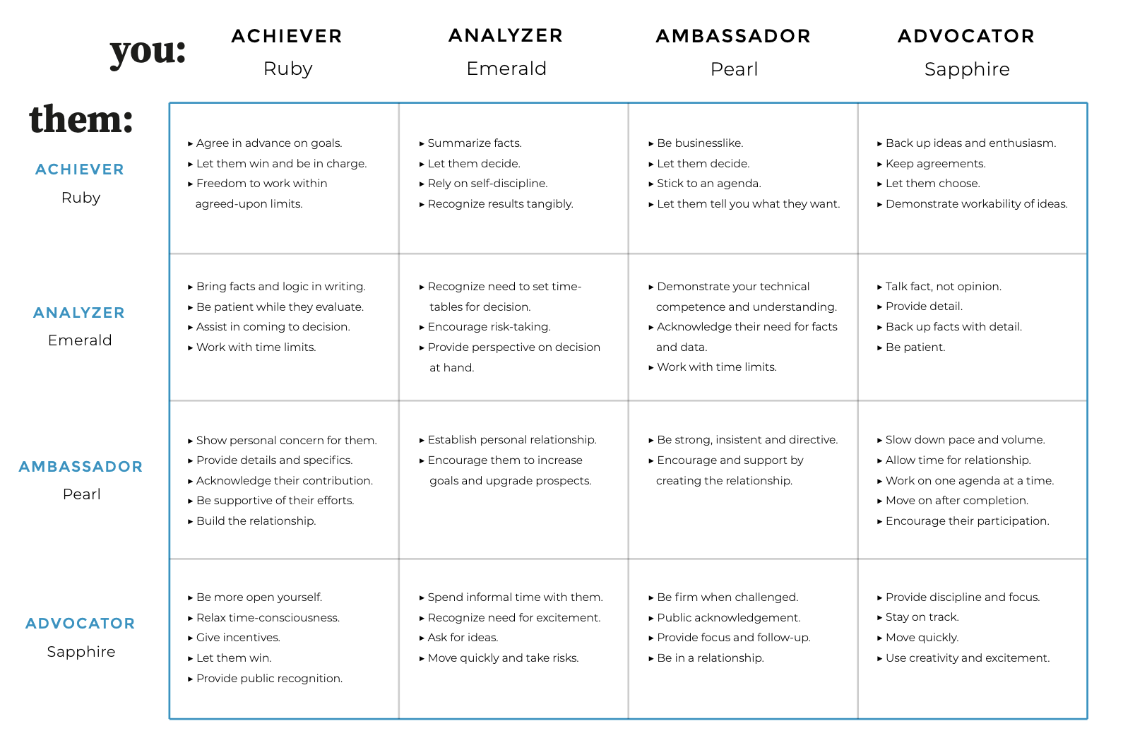

Re-read this matrix a few times over. Print it off. Have it on hand. Learn how each relationship differs, and most importantly, how you can take control of any interaction no matter what.

Remember, the point is not so you can manipulate others or feel powerful and dominant.

Instead, understanding these four sales personality types is meant to help you deal with others on a deeper level.

This is what will allow you to form real connections with your sales prospects. It will let you connect with them in a way only a few people try, so you can start a relationship in the best possible manner and have a huge impact thereafter.

This is the mindset you need if you want to truly succeed in the long term—not only in sales but also in life.

**Wrapping Up**

Not taking the time to understand your own personality type does you and everyone around you a disservice. Similarly, not considering your prospects’ personality types increases the likelihood of misunderstanding, miscommunication, and conflict.

In any sales call or meeting, your job is to listen and guide the other person so you can better understand their pain and what solution they need. However, remember all the while that you should remain you. You can adapt and adjust, but you are who you are. Your strengths are your strengths, and your weaknesses are your weaknesses.

It isn’t that one sales personality type is better than another. They all have many benefits, and they each have flaws. All you can do is embrace who you are. As long as you understand what you do and why you do it, you can remain in control.

**Important Traits of a Realtor**

* Care about the clients interest
* Be confident
* Be current
* Be resilient (Top sales achievers have a unique ability to cope with difficulty to negotiate obstacles to optimize performance in the face of adversity)
* Socialize
* Good listener
* Multitask (nurture, follow up, potential leads, close deals)
* Honest and Optimistic
* Persistent and be focused

**Connect with Us at The Sales Connection**

Looking to connect with a sales team that can scale your business?

Aside from linking clients to the best sales professionals, we help businesses grow through custom-tailored strategies backed by decades of experience. Reach out to [**join our team**](https://thesalesconnection.com/get-hired) or [**learn how we can work together**](https://thesalesconnection.com/recruit).